Name _________________________________________ Date _________________ Period _______
Seasons & the Tilt
Part 1: Use the diagram below to draw the position of earth that matches the description for the Northern Hemisphere in the data chart.
South Pole
North Pole
EQUATOR

Summer Solstice  Approximate hours of Sunlight __________  Date Occurs ____________________________ | Spring Equinox  Approximate hours of Sunlight __________  Date Occurs ____________________________
Winter Solstice  Approximate hours of Sunlight __________  Date Occurs ____________________________ | Autumn Equinox  Approximate hours of Sunlight __________  Date Occurs ____________________________

Part 2: Label the diagram below with the following terms: Summer, Winter, Spring, Fall, Spring Equinox, Autumn Equinox, Winter Solstice & Summer Solstice
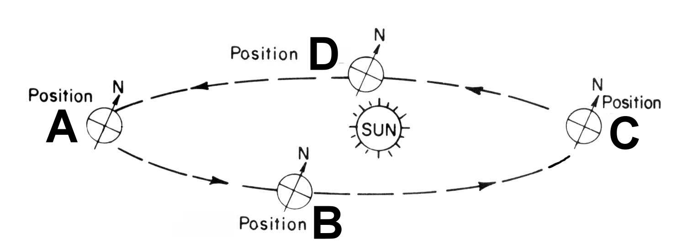

Part 3: Answer the following questions based on what you have learned.
When it is summer in the southern Hemisphere, what season is it in the northern Hemisphere?

During a _________________________ the Earth’s axis is not tilted away or towards the sun?

During an equinox the sun’s rays are most direct over the __________________________.

During a the summer solstice in the Northern Hemisphere the sun’s rays are most direct over the __________________________.

Explain how the tilt of earth’s axis relates to seasons. ____________________________________________________________________________________________________________________________________________________________________________________

What do you think would be the effect on seasons if the axis of Earth were not tilted?
____________________________________________________________________________________________________________________________________________________________________________________

