The Universe and Electromagnetic Spectrum
State Objectives 2e. and 4.f.
What are Electromagnetic Waves?
- Form of ____________ that travels at the speed of light (300,000 km/s)
  - Uses electric and magnetic fields
- Can travel through a ______________ (empty space)
- Two Characteristics
    - ____________- distance between two points on a wave
    - ____________- number of waves that pass a point in one second
Electromagnetic __________ is a collection of EM waves of all known frequencies.
Properties of Waves
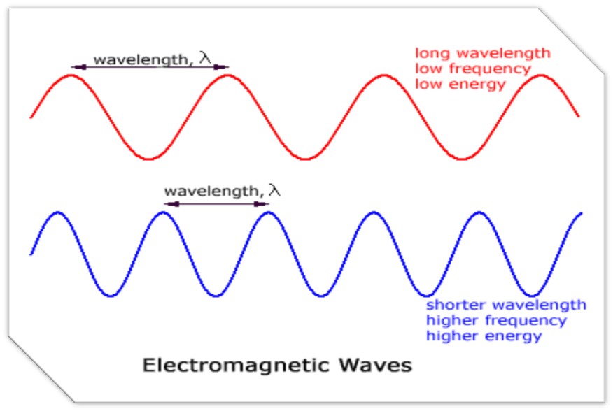
Types of Electromagnetic Waves
__________: carry the most energy
- Shortest wavelength & highest frequency
- Produced by hottest objects in universe
- Kills living cells
- Used to sterilize medical equipment, kill bacteria in food, and treat cancer
_______________: high energy through soft tissue & matter, but lower energy in hard tissue & matter
- Can damage or kill living cells, so precautions must be taken
- Used in medical imaging and security screening devices
__________________: Have both positive and negative effects on living organisms
- Helps produce _______________ in the skin and causes tanning
- Prolonged exposure causes sunburns and skin cancer
- Most UV radiation is blocked by the ____________ layer
- Can be used to disinfect objects and in “blacklights”
_________________: the only part of the spectrum that is detectable by the human eye
- Longer wavelength & lower frequency than UV-rays
- Allows us to see different colors
- Objects reflect the color of the spectrum you see and absorb the other colors
- Order from ____________ wavelength to shortest
- red, orange, yellow, green, blue, indigo, violet (Roy G Biv)
________________: cannot be seen by humans but is felt as __________.
- Wavelengths longer than visible and have frequencies which are lower than visible
- Used in thermal imaging cameras (night vision), and TV remote controls
- Can be used to observe faint objects in space.
________________ Pass easily through earth’s atmosphere so they can be used to transmit signals (TV broadcasts)
- Also used to cook food, in radar detectors, & ______________
- Microwave ovens work by causing water and fat molecules to vibrate.
- Some scientists believe prolonged exposure to microwaves through cells phones and other devices can lead to brain cancer.
______________: carries the least amount of energy
- longest wavelength & lowest frequency
- Main use is _______________
- Different __________________
Draw a line to match the description to the wave type.

Radio Prolonged exposure can harm skin
Microwaves Only part of the spectrum the human eye can detect
Infrared Used to transmit information
Visible light Humans release this in the form of heat
Ultraviolet Used in cell phones. Might cause cancer
X-rays Kills living cells
Gamma rays Damaging to soft tissue, used for medical imaging

THE UNIVERSE
Parts of the Universe
- The _____________ is all space, matter, and energy that exists
- The exact size is unknown, but it is believed to still be expanding outward.
- Stars group together in ______________.
- Clusters group together in ________________.
- Galaxies group together in ____________________.
- Galaxy groups group together in_________________.
_______________
- Huge collection of stars, gas, & dust held together by gravity
- 3 types of galaxies: ___________, ____________, & ____________
Galaxy Groups
- The ________________ (our galaxy) is located in the _______________.
- The Local Group contains 36 galaxies.
- The Local Group is part of the _______________________ (at least 100 galaxies).
Our Galaxy - The Milky Way
- From the side, the Milky Way appears to be a narrow disk with a bulge in the middle. The galaxy’s spiral structure is visible only from above or below.

___________
- Stars are objects made of gases which produce light and heat from ______________ reactions inside the star.
- Smaller stars fuse _____________ into ______________. Larger stars form heavier elements.
- Stars form & end their life in nebulae:
Nebulae (singular “nebula”)
___________________ are large clouds of gas, plasma & dust within a galaxy
- Typically a few light-years wide.
- ___________________ is the distance light travels in one year (about 9.5 trillion km)
How far away are stars?
- _____________________: apparent shift in the position of an object when view from two different locations.
- Can be used to measure the distance of stars from Earth that are relatively close.
- ______________________: closest star to earth
  - (4.3 light years away – 40 trillion km)
The Expanding Universe
- All distant galaxies are moving rapidly ___________ from our galaxy and from each other.
- The galaxies in the universe are like the raisins in rising bread dough.
- ______________: occurs when a star or other object is moving away from Earth
- ______________: occurs when a star or other object is moving toward Earth
Origins of the Universe
- ____________________: states that all matter and energy were once packed into a tiny particle smaller than a speck of dust.
- The particle began to expand and matter and energy moved rapidly outward in all directions.
- The matter cooled and collected to form stars, galaxies, nebulae, and planets.
- Most scientists believe the universe is about _______________ years old.
Telescopes
- ___________________ are instruments that collect and focus light or other forms of electromagnetic radiation.
- Many telescopes use ____________ to collect light from space.
- Space telescopes in orbit provide clearer pictures because_________________________________________________________________________.
Four Views of the Crab Nebula
- Different types of telescopes collect electromagnetic radiation at different ___________________.
- Astronomers are able to learn a great deal about the Crab Nebula by examining these different images.
______________ Space Telescope
- Launched in 1990
- One of NASA’s most successful missions.
- Orbits 353 miles above Earth
- Completes one orbit every 97 minutes

__________________ observatory
- Launched in 1999.
- Detects x-rays from the ______________ regions of the universe
- Orbits Earth at an altitude of ___________________.
- Has observed the _________________ at the center of the Milky Way and discovered several other black holes.
______________ Space Telescope
- Launched in 2003
- Observes ____________ radiation
- ________________ (sun-centered) orbit
- Parts of the telescope must be kept at -450 degrees Fahrenheit so as not to interfere with infrared detection.
___________________ Telescope
- Currently being built to replace Hubble
- Scheduled to launch in 2018
- Will observe radiation in _________________ and _____________________
- Will be able to see galaxies that have shifted beyond visible spectrum

