The Universe and Electromagnetic Spectrum
State Objectives 2e. and 4.f.
What are Electromagnetic Waves?
- Form of energy that travels at the speed of light (300,000 km/s)
  - Uses electric and magnetic fields
- Can travel through a vacuum (empty space)
- Two Characteristics
    - Wavelength- distance between two points on a wave
    - Frequency- number of waves that pass a point in one second
Electromagnetic spectrum is a collection of EM waves of all known frequencies
Properties of Waves
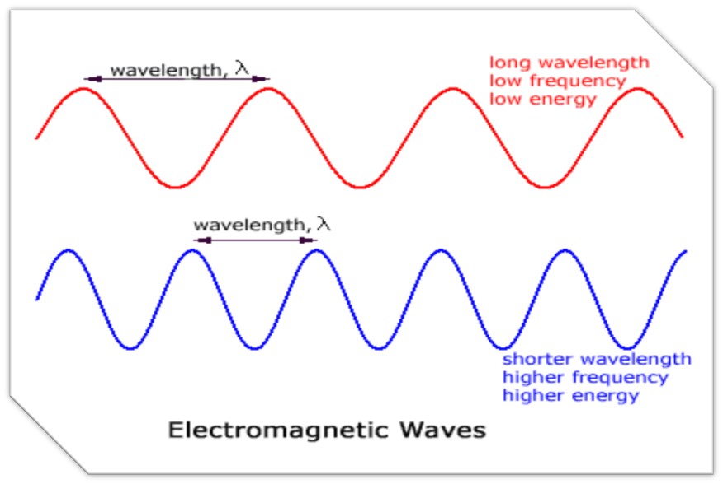
Types of Electromagnetic Wavesd
Gamma: carry the most energy
- Shortest wavelength & highest frequency
- Produced by hottest objects in universe
- Kills living cells
- Used to sterilize medical equipment, kill bacteria in food, and treat cancer
X-rays: high energy through soft tissue & matter, but lower energy in hard tissue & matter
- Can damage or kill living cells, so precautions must be taken
- Used in medical imaging and security screening devices
Ultraviolet (UV) rays: Have both positive and negative effects on living organisms
- Helps produce vitamin D in the skin and causes tanning
- Prolonged exposure causes sunburns and skin cancer
- Most UV radiation is blocked by the ozone layer
- Can be used to disinfect objects and in “blacklights”
Visible light: the only part of the spectrum that is detectable by the human eye
longer wavelength & lower frequency than UV-rays
- Allows us to see different colors
- Objects reflect the color of the spectrum you see and absorb the other colors
- Order from longest wavelength to shortest
- red, orange, yellow, green, blue, indigo, violet (Roy G Biv)
Infrared: cannot be seen by humans but is felt as heat.
- Wavelengths longer than visible and have frequencies which are lower than visible
- Used in thermal imaging cameras (night vision), and TV remote controls
- Can be used to observe faint objects in space.
Microwaves Pass easily through earth’s atmosphere so they can be used to transmit signals (TV broadcasts)
- Also used to cook food, in radar detectors, & cell phones
- Microwave ovens work by causing water and fat molecules to vibrate.
- Some scientists believe prolonged exposure to microwaves through cells phones and other devices can lead to brain cancer.
Radio waves: carries the least amount of energy
- longest wavelength & lowest frequency
- Main use is communication
- Different frequencies
Draw a line to match the description to the wave type.

Radio Prolonged exposure can harm skin
Microwaves Only part of the spectrum the human eye can detect
Infrared Used to transmit information
Visible light Humans release this in the form of heat
Ultraviolet Used in cell phones. Might cause cancer
X-rays Kills living cells
Gamma rays Damaging to soft tissue, used for medical imaging

THE UNIVERSE
Parts of the Universe
- The universe is all space, matter, and energy that exists
- The exact size is unknown, but it is believed to still be expanding outward.
- Stars group together in clusters.
- Clusters group together in galaxies.
- Galaxies group together in groups.
- Galaxy groups group together in super-clusters.
Galaxies
- Huge collection of stars, gas, & dust held together by gravity
- 3 types of galaxies: elliptical, spiral, & irregular
Galaxy Groups
- The Milky Way (our galaxy) is located in the Local Group.
- The Local Group contains 36 galaxies.
- The Local Group is part of the Virgo Supercluster (at least 100 galaxies).
Our Galaxy - The Milky Way
- From the side, the Milky Way appears to be a narrow disk with a bulge in the middle. The galaxy’s spiral structure is visible only from above or below.

Stars
- Stars are objects made of gases which produce light and heat from fusion reactions inside the star.
- Smaller stars fuse hydrogen into helium. Larger stars form heavier elements.
- Stars form & end their life in nebulae:
Nebulae
Nebulae are large clouds of gas, plasma & dust within a galaxy
- Typically a few light-years wide.
- Light-year is the distance light travels in one year (about 9.5 trillion km)
How far away are stars?
- Parallax: apparent shift in the position of an object when view from two different locations.
- Can be used to measure the distance of stars from Earth that are relatively close.
- Proxima Centauri: closest star to earth
  - (4.3 light years away – 40 trillion km)
The Expanding Universe
- All distant galaxies are moving rapidly away from our galaxy and from each other.
- The galaxies in the universe are like the raisins in rising bread dough.
- Red Shift: occurs when a star or other object is moving away from Earth
- Blue Shift: occurs when a star or other object is moving toward Earth
Origins of the Universe
- Big Bang Theory: states that all matter and energy were once packed into a tiny particle smaller than a speck of dust.
- The particle began to expand and matter and energy moved rapidly outward in all directions.
- The matter cooled and collected to form stars, galaxies, nebulae, and planets.
- Most scientists believe the universe is about 13.7 billion years old.
Telescopes
- Telescopes are instruments that collect and focus light or other forms of electromagnetic radiation.
- Many telescopes use mirrors to collect light from space.
- Space telescopes in orbit provide clearer pictures because the atmosphere distorts images and absorbs some radiation.
Four Views of the Crab Nebula
- Different types of telescopes collect electromagnetic radiation at different wavelengths.
- Astronomers are able to learn a great deal about the Crab Nebula by examining these different images.
Hubble Space Telescope
- Launched in 1990
- One of NASA’s most successful missions.
- Orbits 353 miles above Earth
- Completes one orbit every 97 minutes

Chandra X-ray observatory
- Launched in 1999.
- Detects x-rays from the hottest regions of the universe
- Orbits Earth at an altitude of 86,500 miles.
- Has observed the black hole at the center of the Milky Way and discovered several other black holes.
Spitzer Space Telescope
- Launched in 2003
- Observes infrared radiation
- Heliocentric (sun-centered) orbit
- Parts of the telescope must be kept at -450 degrees Fahrenheit so as not to interfere with infrared detection.
James Webb Telescope
- Currently being built to replace Hubble
- Scheduled to launch in 2018
- Will observe radiation in infrared and visible light
- Will be able to see galaxies that have shifted beyond visible spectrum

